This paragraph will discuss the costs associated with the project and any potential gain that this project can bring. It is intended to see if the project is justified to continue.

To create context for the following a potential end product has been sketched. The product is as follows:

* An antivirus system for consumers
* An algorithm for businesses

The antivirus system will be sold on a subscription base to consumers on their smarthpones. With the data that is provided through the app the machine learning can be improved. The algorithm can improve through this data which in turn can be sold to companies. This improved algorithm improves the antivirus. The antivirus will then generate data again to improve the algorithm. And so the cycle continues. For a visual explanation see Appendix III.

## Current status

The current HoneyJar project has a funding of €40.000 which has been granted from the Danish Research Network. So the €40.000 will be used as the whole funding for the entire project.

When this project is concluded in half a year ideally the envisioned product is finished. Realistically this won’t be possible since the architecture that is currently standing is very basic and needs a lot of improving. When this is done Machine Learning has to be implemented. Since the project members that are going to work on this aren’t familiar with Machine Learning, this will take a lot of time as well.

Whenever an antivirus is created there has to be a good understanding of the operating system it will run on, in this case that will be Ubuntu. The group has to be up-to-date with malware trends so that it can update the system accordingly. Even with Machine Learning in place it is important to give updates where needed. If Machine Learning will be the only way of detecting malware, new malware might slip through the cracks. Also a proper programming language must be mastered, this will most likely be Python.

So now the following has been established:

1. Architecture needs a lotof work
2. Machine learning is a new expertise to master for the current project group
3. There probably won’t be enough time to finish the created vision

Even though there probably won’t be enough time to finish an end product it is still possible to create an estimate on the revenue that the potential finished product will make.

## Required funds

So let’s say that this product will cost €40.000 to make. With this €40.000 a basic product will be made to show the basic functionalities. Further development will require more money. Also, for this example assume that the product will be sold as a service to consumers who will pay an average of €60 per calendar year.

So right now the product is a SaaS with a subscription for consumers. €40.000 Is a relatively small amount to create an app this size but it will serve as the baseline to create the fundamental features.

Labor costs will be included in the €40.000 for now. As said previously this will include all the work to create a basic system. However with this basic system money will not be earned, yet. For this future development is needed. Since it is hard to predict the future an assumption has to be made on how long this development will take.

Now that a product has been sketched an assumption can be made about the money it will cost and bring in once it’s finished. This has been illustrated in the table below.

|  |  |  |
| --- | --- | --- |
| Task | Estimated € needed | Comment |
| Basic system development | € 40.000 |  |
| Development for a marktable product | € 300.000 |  |
| Total development costs | € 340.000 |  |
|  |  |  |
|  |  |  |
| Future improvements and support costs (annually) | € 120.000 |  |
| Partnership costs | € 31.250.000 | 25% of profit |
| Marketing | € 12.500.000 | 10% of profit |
| Brand development | € 12.500.000 | 10% of profit |
| Total | € 56.370.000 |  |
|  |  |  |
| Gained money (annual) |  |  |
| Subscription | € 120.000.000 | avg €5p/month with 2million users |
| Machine learning algotrithm | € 5.000.000 | avg €5000p/month with 1000 businesses |
| Total | € 125.000.000 |  |
|  |  |  |
|  |  |  |
| Actual profit per year | € 68.630.000 |  |

Development for a marketable product has a price of €300.000, because the assumption has been made that it’ll be developed by people that’ll work on this app full time (40hrs/week) for a period ranging from half a year to a year.

## Business model canvas

A Business Model Canvas (BMC for short) is an excellent way to showcase the different stakeholders inside a business, in our case the Honeyjar.

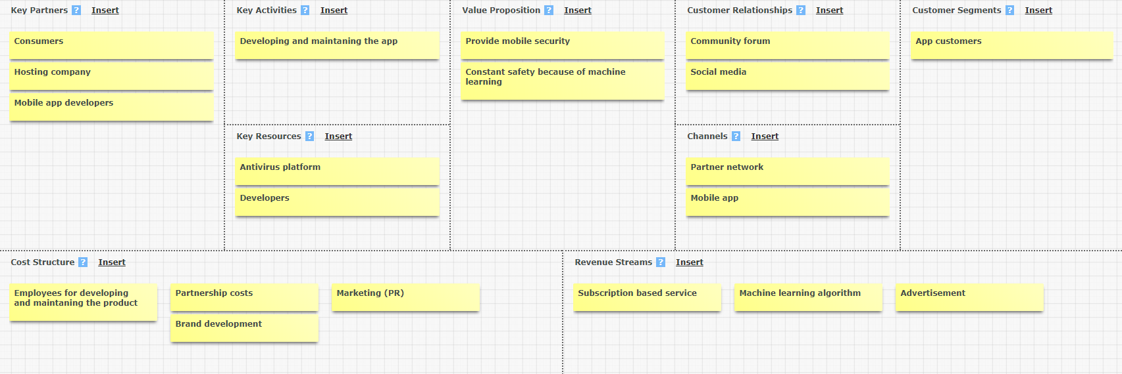

Figure 3: A Business Model Canvas for Honeyjar

## BMC Context

### Key partners

Some activities are outsourced and some resources are acquired outside the enterprise. So in short, the relevant stakeholders for the business in question.

### Key resources

Key resources are the assets required to offer and deliver the product…

### Key activities

..By performing a number of Key activities.

### Value proposition

Seeks to solve customer problems and satisfy customer needs with value proportions

### Customer relationships

Customer relationships are established and maintained with each Customer Segment

### Channels

Value propositions are delivered to customers through communication, distribution, and sales channels.

### Customer segments

An organization serves one or several customer segments. These can also be seen as target groups.

### Cost structure

The business model elements result in the cost structure.

### Revenue streams

Revenue streams result from value propositions successfully offered to customers. In other words, this shows in what ways the company can generate income